D**ATA SCIENCE & MACHINE LEARNING**

**LAB CYCLE 3**

**Mathplotlib**

**Demonstrate creating various types of charts and plots using functions in mathplotlib library**

1. Sarah bought a new car in 2001 for $24,000. The dollar value of her car changed each year as shown in the table below.

**Value of Sarah's Car**

**Year Value**

**2001 $24,000**

**2002 $22,500**

**2003 $19,700**

**2004 $17,500**

**2005 $14,500**

**2006 $10,000**

**2007 $ 5,800**

Represent the following information using a line graph with following style properties

* **X- axis - Year**

**Y –axis - Car Value**

* **title –Value Depreciation (left Aligned)**
* **Line Style dashdot and Line-color should be red**
* **point using * symbol with green color and size 20**

Subplot() provides multiple plots in one figure.

**Program**

import matplotlib.pyplot as plt

import numpy as np

xpoints = np.array([2001, 2002,2003,2004,2005,2006,2007])

ypoints = np.array([24000, 22500,19700,17500,14500,10000,5800])

plt.plot(xpoints, ypoints, '*g',ms = 20)

plt.plot(xpoints, ypoints, ':r')

leg = plt.legend(title="Value Depreciation ")

leg._legend_box.align = "left"

plt.show()

**Output**

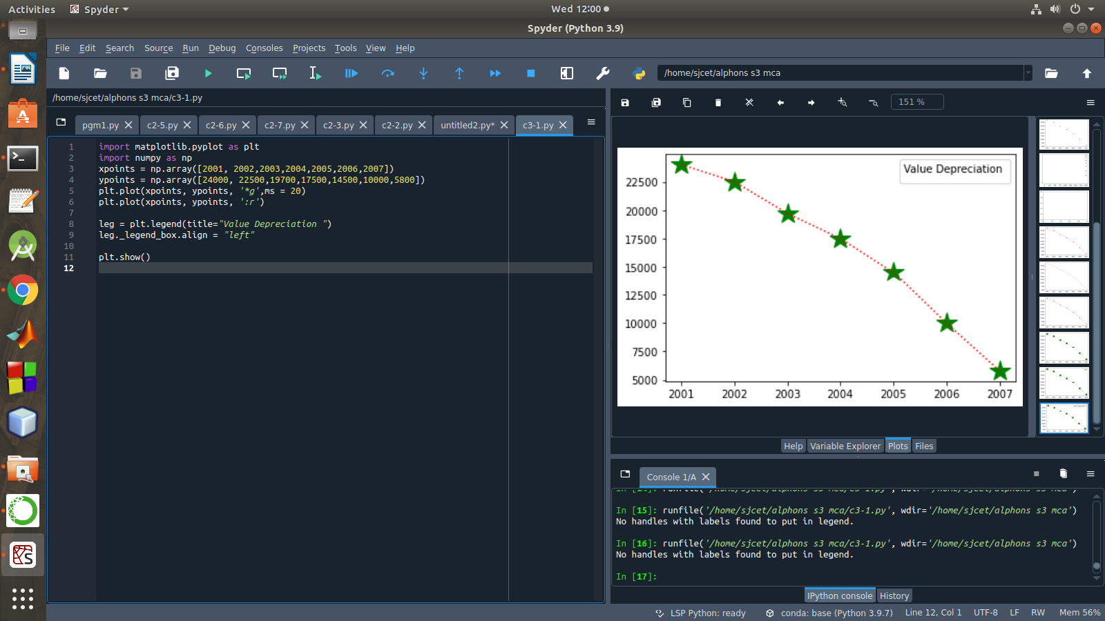

1. Following table gives the daily sales of the following items in a shop

|  |  |  |  |  |  |
| --- | --- | --- | --- | --- | --- |
| Day | Mon | Tues | Wed | Thurs | Fri |
| Drinks | 300 | 450 | 150 | 400 | 650 |
| Food | 400 | 500 | 350 | 300 | 500 |

Use subplot function to draw the line graphs with **grids(color as blue** and line style dotted) for the above information as 2 separate graphs in two rows

1. Properties for the Graph 1:

* X label- Days of week
* Y label-Sale of Drinks
* Title-Sales Data1 (right aligned)
* Line –dotted with cyan color
* Points- hexagon shape with color magenta and outline black

1. Properties for the Graph 2:

* X label- Days of Week
* Y label-Sale of Food
* Title-Sales Data2 ( center aligned)
* Line –dashed with yellow color
* Points- diamond shape with color green and outline red

**Program**

import matplotlib.pyplot as plt

import numpy as np

#plot 1:

x = np.array(['mon', 'tue', 'wed', 'thur','fri'])

y = np.array([300, 450, 150, 400,65])

plt.subplot(1, 2, 1)

plt.title("Sales Data1")

plt.xlabel("Days of week")

plt.ylabel("Sale of Drinks")

plt.plot(x,y,':c')

plt.plot(x,y,'Hm',mec = 'k')

plt.grid(color = 'blue', linestyle = 'dotted')

#plot 2:

c = np.array(['mon', 'tue', 'wed', 'thur','fri'])

v = np.array([400, 500, 350, 300,500])

plt.subplot(1, 2, 2)

plt.title("Sales Data2")

plt.xlabel("Days of Week")

plt.ylabel("Sale of Food")

plt.plot(c,v,'--y')

plt.plot(c,v,'Dg',mec = 'r')

plt.grid(color = 'blue', linestyle = 'dotted')

plt.show()

**Output**

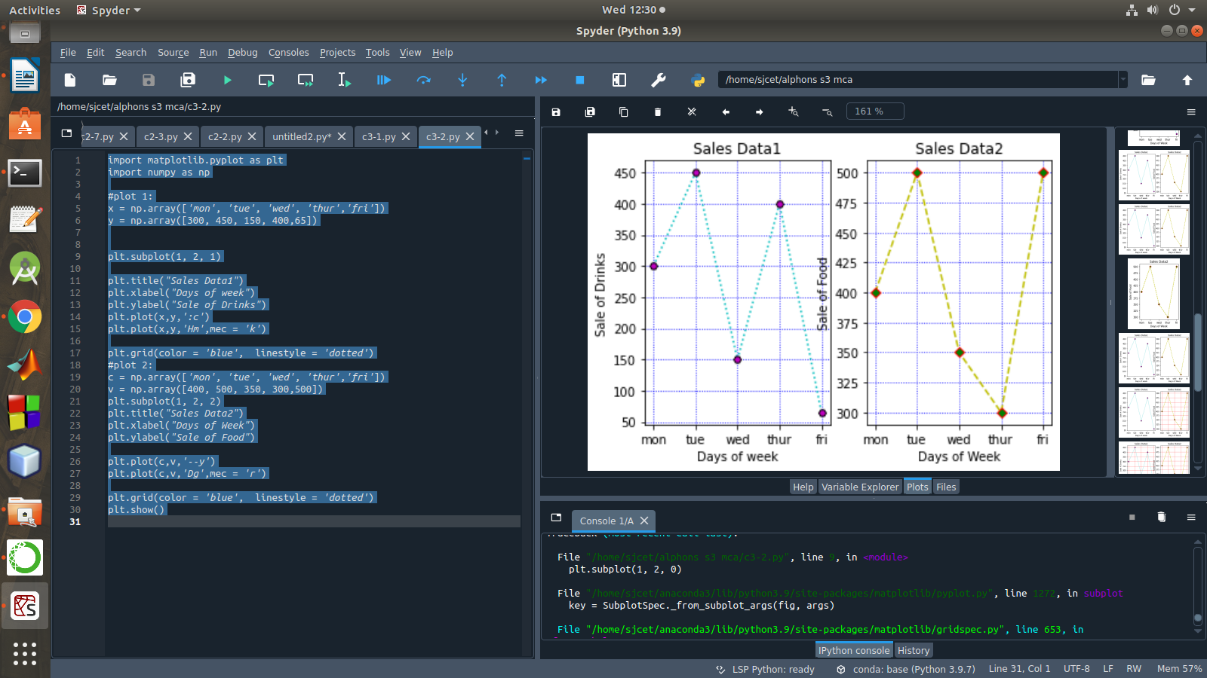

1. Create scatter plot for the below data:(use Scatter function)

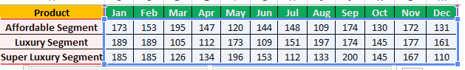

Create scatter plot for each Segment with following properties within one graph

* X Label- Months of Year with font size 18
* Y-Label- Sales of Segments
* Title –Sales Data
* Color for Affordable segment- pink
* Color for Luxury Segment- Yellow
* Color for Super luxury segment-blue

**Program**

import matplotlib.pyplot as plt

import numpy as np

plt.title("Sales Data")

plt.xlabel("Months of Year")

plt.ylabel("Sale of Food")

x = np.array([173,153,195,147,120,144,148,109,174,130,172,131])

y = np.array([173,153,195,147,120,144,148,109,174,130,172,131])

plt.scatter(x,y, color = 'hotpink')

x = np.array([185,185,126,134,196,153,112,133,200,145,167,110])

y = np.array([185,185,126,134,196,153,112,133,200,145,167,110])

plt.scatter(x, y, color = 'yellow')

x = np.array([189,189,105,112,173,109,151,197,174,145,177,161])

y = np.array([189,189,105,112,173,109,151,197,174,145,177,161])

plt.scatter(x, y, color = 'blue')

plt.show()

**Output**

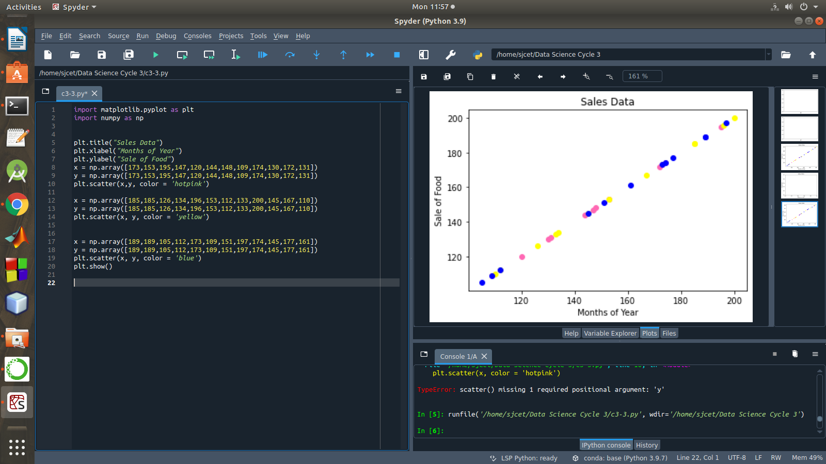

1. Display the above data using multiline plot( 3 different lines in same graph)

* Display the description of the graph in upper right corner(**use legend())**
* Use different colors and line styles for 3 different lines

1. 100 students were asked what their primary mode of transport for getting to school was. The results of this survey are recorded in the table below. Construct a bar graph representing this information.

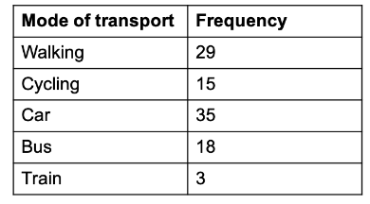

Create a bar graph with

* X axis -mode of Transport and Y axis ‘frequency’
* Provide appropriate labels and title
* Width .1, color green

Program

import matplotlib.pyplot as plt

import numpy as np

plt.title("Students transportation")

plt.xlabel("Mode of Transport")

plt.ylabel("Frequency")

x = np.array(["walking","cycling","car","bus","train"])

y = np.array([29,15,35,18,3])

plt.bar(x, y, color = "#4CAF50",width = 0.1)

plt.show()

Output

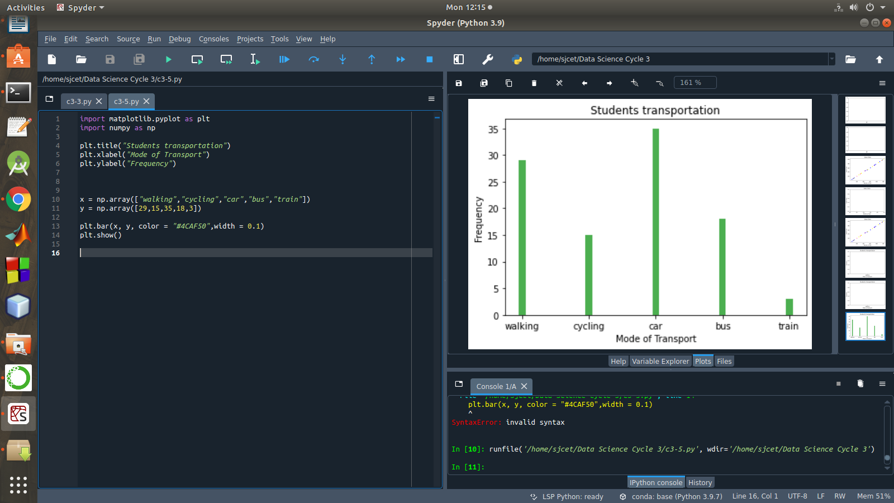

1. We are provided with the height of 30 cherry trees.

The height of the trees (in inches): 61, 63, 64, 66, 68, 69, 71, 71.5, 72, 72.5, 73, 73.5, 74, 74.5, 76, 76.2, 76.5, 77, 77.5, 78, 78.5, 79, 79.2, 80, 81, 82, 83, 84, 85, 87.Create a histogram with a bin size of 5

**Program**

import matplotlib.pyplot as plt

height = [61,63,64,66,68,69,

71,71.5,72,72.5,73,73.5,74,74.5,76,76.2,76.5,77,77.5,78,78.5,79,79.2,80,81,82,83,84,85,87

]

plt.hist(height, edgecolor="red", bins=5)

plt.show()

**Output**

